Appsters Industry Page Layout
SOCIAL MEDIA
Laid out fold by fold against www.appsters.io/industry
 | DETAIL
Slug | social-media-app-development-services
Meta Title | Social Media App Development Company Built To Scale Fast
Meta Description | Feeds, messaging, reels and moderation engines that hold up at millions of users. Appsters builds social apps that survive going viral. Talk to us.
Layout Source | www.appsters.io/industry
Live Folds | 23
New Blocks Required | 3
FOLD 1: Hero Banner
Hero Banner
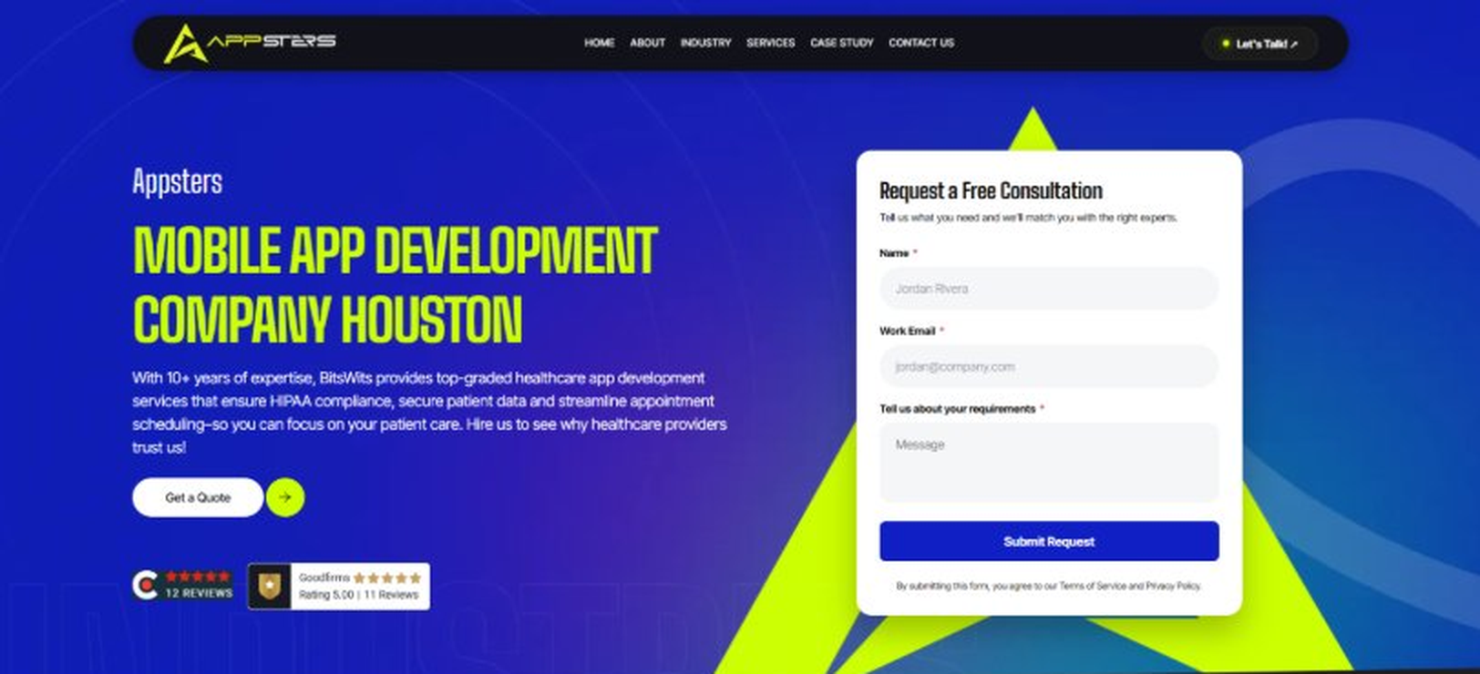
Current live page, www.appsters.io/industry
 | DETAIL
Status | New copy applied
Build Notes | Live block holds H1, sub copy, a Get a Quote button and the Request a Free Consultation form. New copy supplies the H1 and sub copy only.
QA Flag | Live hero copy currently names BitsWits and describes healthcare services. Leftover copy from another build, replace it with the new copy below.
Copy For This Fold
PAGE ELEMENT | COPY (WORD FOR WORD)
H1 (Page Heading) | A High-Performing Social Media App Development Company Building Platforms People Actually Use
Body Copy | Attention spans are shrinking, and new platforms rise and fall within months. As a social media app development company, Appsters builds Social Media apps that hold attention through smart architecture, not gimmicks. We design feeds, messaging systems, and content engines that scale from a few thousand early users to millions of daily active users without breaking under load. Every product we ship is built to survive the moment it actually starts working, not just the demo.
FOLD 2: Marquee Strip
Marquee Strip: Turn Your Wildest Ideas Into Powerful Digital Products
Current live page, www.appsters.io/industry
 | DETAIL
Status | No copy change
Build Notes | No new copy in the source document for this fold. Keep the live block exactly as it is.
FOLD 3: Stats Counter
Stats Counter: Work With A Local Mobile App Developer In Houston
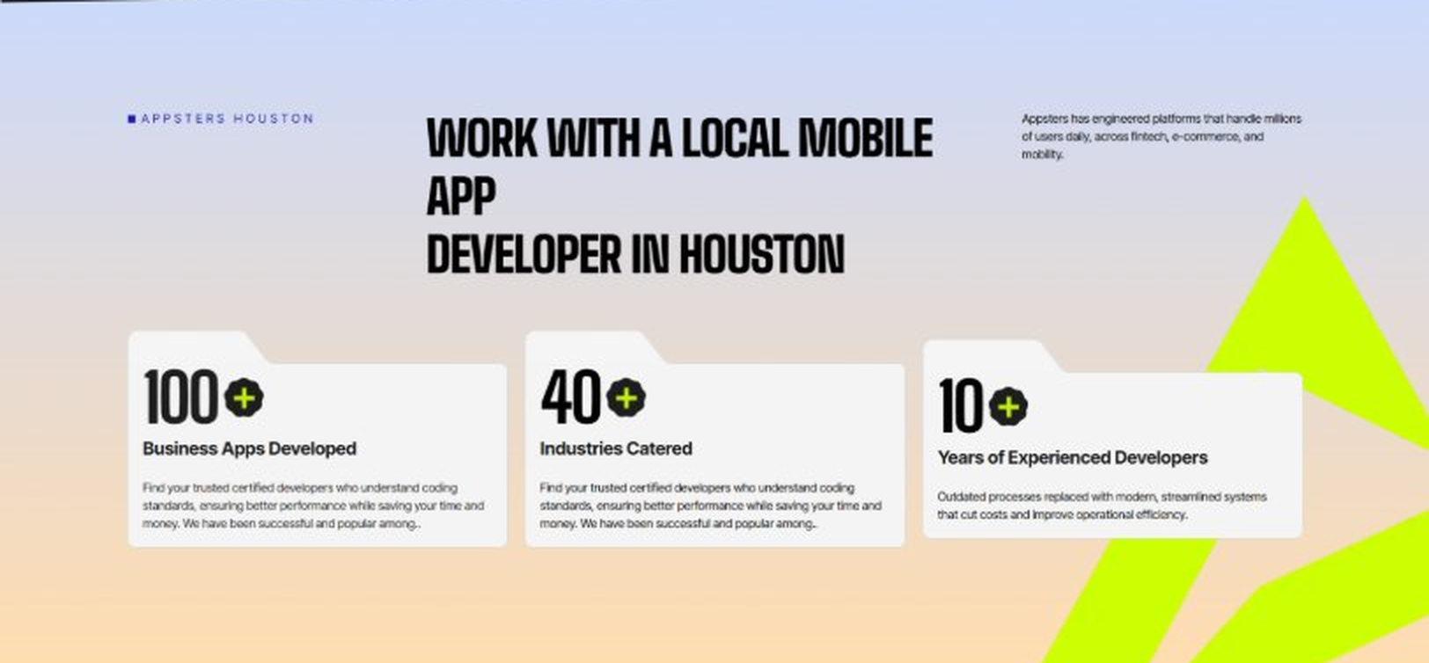
Current live page, www.appsters.io/industry
 | DETAIL
Status | New copy applied
Build Notes | Live block holds 3 counters. New copy holds 6 stats. Either widen the block to 6 or drop two.
Copy For This Fold
PAGE ELEMENT | COPY (WORD FOR WORD)
H2 (Section Heading) | Awarded For Building Social Media Apps That Scale Without Breaking
Body Copy | Our Social Media app development work has earned recognition for engagement design, infrastructure stability, and measurable retention gains. Appsters has been recognized for delivering platforms that balance creative UX with engineering discipline, apps that load instantly, moderate content responsibly, and stay reliable through unpredictable viral spikes. Every award reflects tested performance, not a polished pitch deck.
Stat 1 Number | 40+
Stat 1 Label | Industries Served
Stat 1 Copy | Our experience spans social platforms, marketplaces, fintech, healthcare, and more, with solutions adapted to each sector's demands for security, AI, compliance, and user adoption.
Stat 2 Number | 3000+
Stat 2 Label | Apps and Solutions Delivered
Stat 2 Copy | Thousands of projects executed with an emphasis on speed, AI adoption, stability, and clear ROI across both startup and enterprise environments.
Stat 3 Number | 60+
Stat 3 Label | AI Models Deployed
Stat 3 Copy | Every model is designed for high accuracy, reliable outputs, and performance at scale for mission-critical workflows and more.
Stat 4 Number | 50,000+
Stat 4 Label | Legacy Processes Modernized
Stat 4 Copy | Outdated processes replaced with modern, streamlined systems that cut costs and improve operational efficiency.
Stat 5 Number | 250+
Stat 5 Label | Engineers and Designers
Stat 5 Copy | A global team skilled in native mobile app development, AI-driven ecosystems, cross-platform builds, and enterprise architecture.
Stat 6 Number | 95%
Stat 6 Label | Client Retention
Stat 6 Copy | Long-term partnerships built on trust, consistent delivery, and continuous optimization of live applications.
FOLD 4: Marquee Strip
Marquee Strip: Mobile App Development Services
Current live page, www.appsters.io/industry
 | DETAIL
Status | No copy change
Build Notes | No new copy in the source document for this fold. Keep the live block exactly as it is.
FOLD 5: Services Grid
Services Grid: Our Comprehensive Mobile App Development Services In Houston
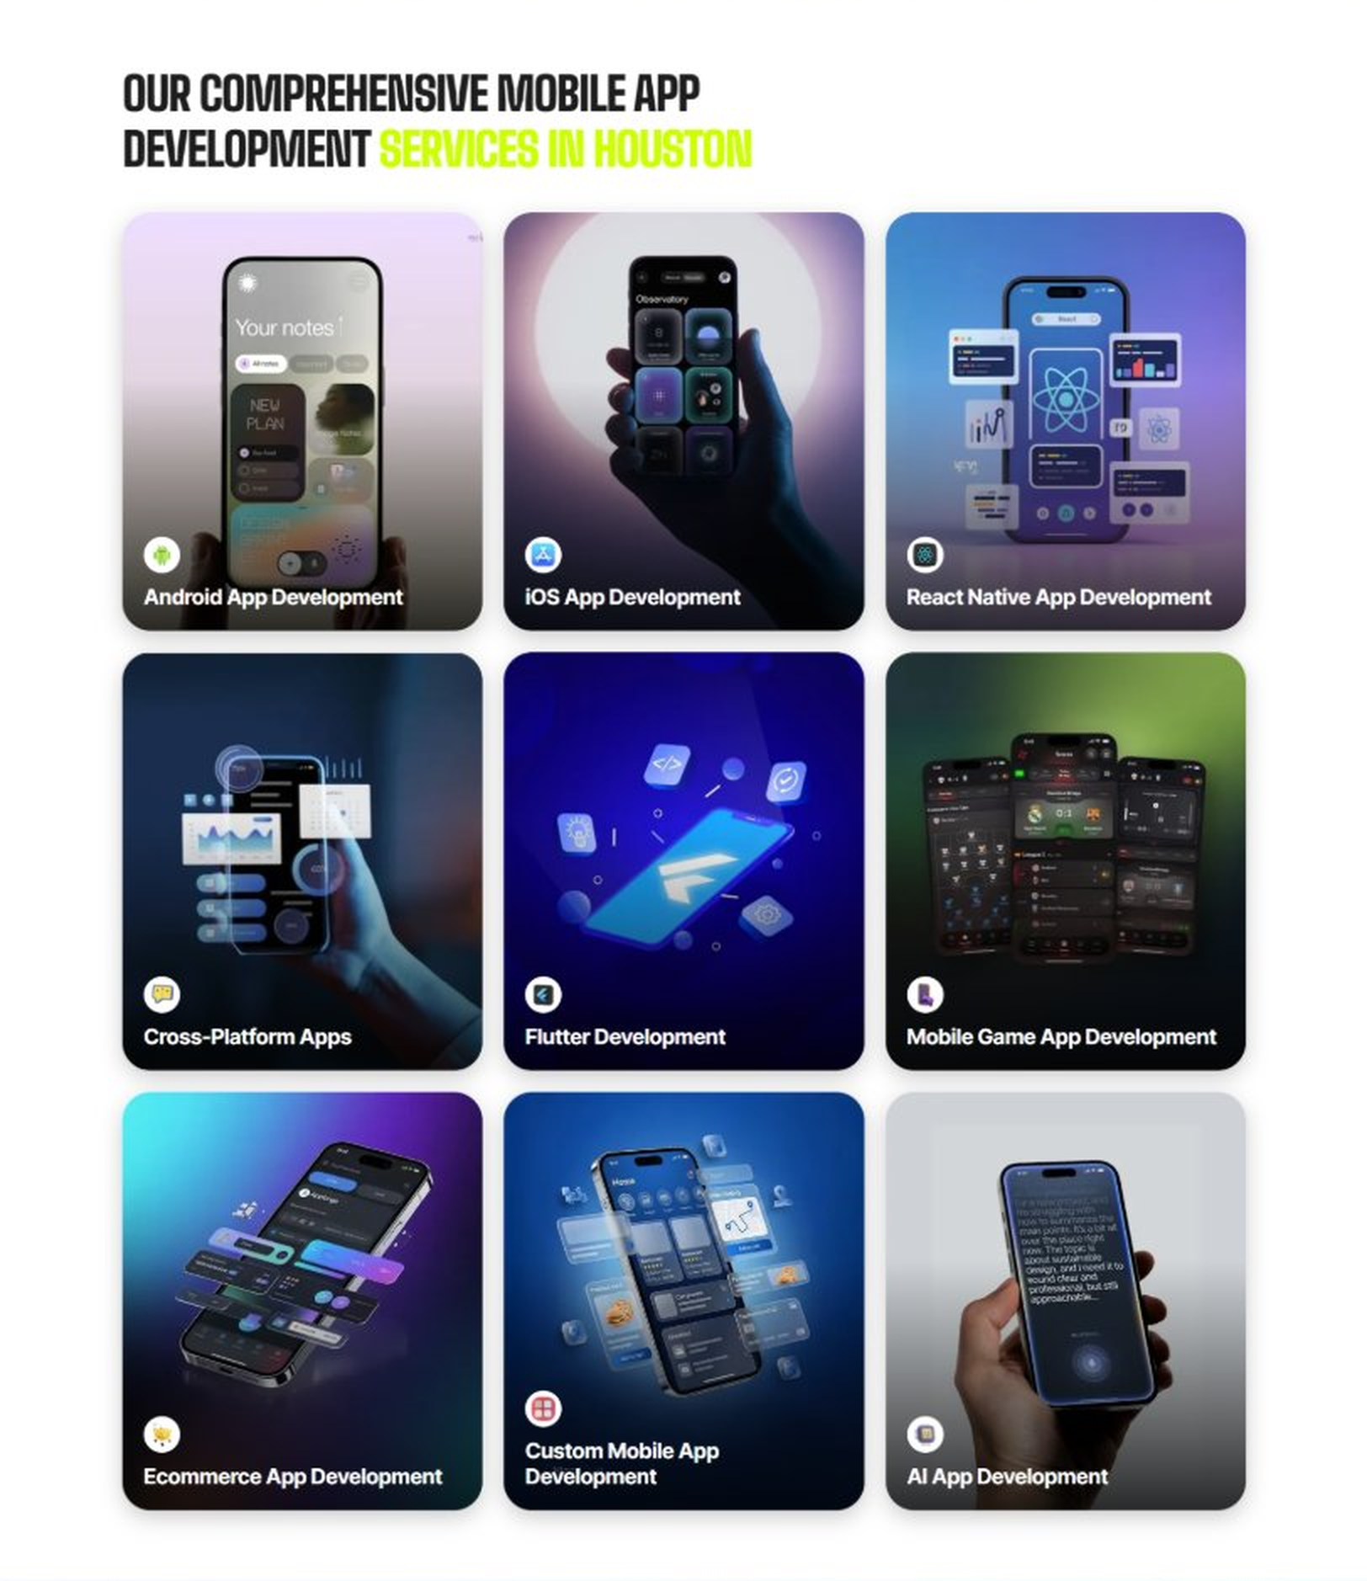
Current live page, www.appsters.io/industry
 | DETAIL
Status | New copy applied
Build Notes | Live grid holds 9 cards. New copy holds 5 services. Either trim the grid to 5 or brief four more services.
Copy For This Fold
PAGE ELEMENT | COPY (WORD FOR WORD)
H2 (Section Heading) | Social Media Application Development Services Built For Communities That Stay Active
Body Copy | Strong social platforms sit at the crossroads of design, moderation, and infrastructure. As a social media app development company, we connect creative product thinking with technical precision. Appsters' senior developers build platforms that support real-time feeds, secure messaging, content discovery, and monetization tools for creators, brands, and everyday users. We treat each of these as its own discipline instead of bundling them into a generic app template, which is usually where competitor builds start to fall apart.
Service 1 Heading | Social Media Finder App Development
Service 1 Copy | As Social Media app developers, we build discovery layers that help users find communities, creators, and content that actually match their interests. Smart recommendation logic, location-aware discovery, and interest graphs replace generic feeds with something users keep coming back to. We tune these systems continuously against real usage data instead of shipping them once and walking away.
Service 2 Heading | Food Ordering App Development
Service 2 Copy | Social commerce is now a core part of how people shop, and our food ordering app developers know how to embed ordering flows directly into a social feed. From in-app checkout to creator-led promotions, we help social platforms turn engagement into transactions without disrupting the scroll.
Service 3 Heading | Food Delivery App Development
Service 3 Copy | As a food delivery app development company, we build logistics layers that plug straight into social platforms, live order tracking, delivery partner apps, and notification systems that keep users updated without leaving the app they already trust.
Service 4 Heading | Discounts App Development
Service 4 Copy | Our Social Media discounts app development work helps platforms reward loyal users and creators with redeemable perks, flash promotions, and referral-based discounts that drive both retention and word-of-mouth growth.
Service 5 Heading | Social Media Review & POS Software Development
Service 5 Copy | For platforms that blend social discovery with real-world commerce, our POS software development company expertise connects in-app reviews, ratings, and purchase history directly to point-of-sale systems, giving businesses a single, reliable source of truth.
FOLD 6: Case Study CTA
Case Study CTA: HELPP
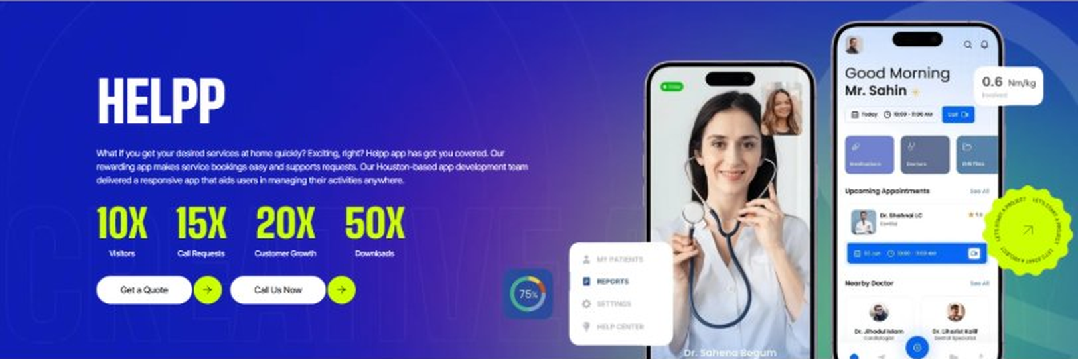
Current live page, www.appsters.io/industry
 | DETAIL
Status | New copy applied
Build Notes | Live block holds a product name, a paragraph, four metric counters and two CTA buttons. New copy supplies the heading and paragraph. Metrics still need to be supplied.
Copy For This Fold
PAGE ELEMENT | COPY (WORD FOR WORD)
H2 (Section Heading) | Social Media App Developers Who Build For Retention, Not Just Downloads
Body Copy | Launching a social app is easy. Keeping users coming back is the hard part. If you're ready to build Social Media apps that people actually stay on, Appsters is the partner that gets you there. Let's talk about your product and map out what a scalable, engaging platform looks like for your audience, and what it will take to get it there without burning your runway on the wrong features first.
FOLD 7: Testimonials
Testimonials: Real Stories From People Who Wanted What’s Next
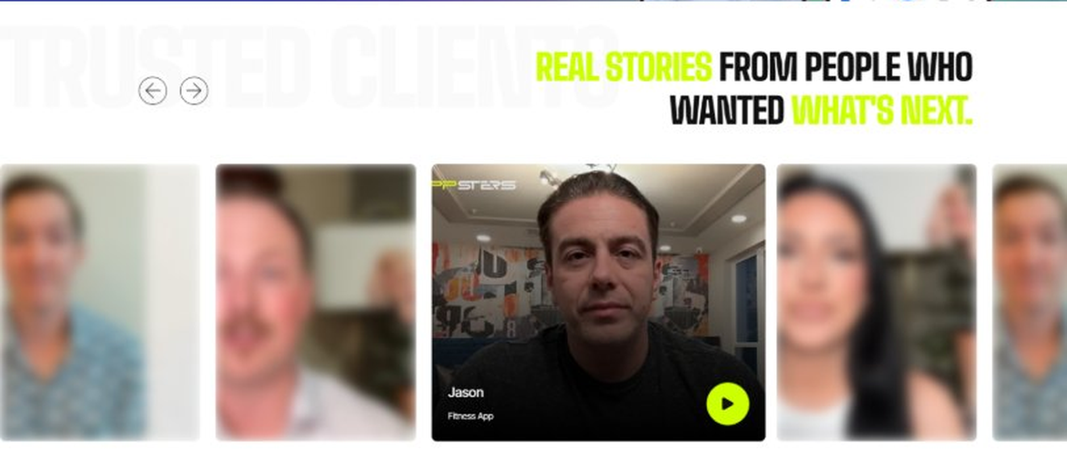
Current live page, www.appsters.io/industry
 | DETAIL
Status | New copy applied
Build Notes | Live block runs video testimonials. New copy is written quotes with attributions. Source document marks this fold design TBD.
Copy For This Fold
PAGE ELEMENT | COPY (WORD FOR WORD)
H2 (Section Heading) | What Our Clients Say
Testimonial 1 Quote | "Honestly, I went in expecting the usual back and forth you get with most dev shops. That's not what happened. The Appsters team pushed back on a couple of feature ideas that would have slowed our onboarding down, and they were right to. Our numbers looked better after month one than I expected them to look after month three."
Testimonial 1 Attribution | Derek Hail, Founder
Testimonial 2 Quote | "We'd already burned through two agencies before this one, both of which folded the second we mentioned real concurrency numbers. Appsters didn't blink. First time we hit a real spike in traffic, nothing fell over. That alone told us we'd picked the right team."
Testimonial 2 Attribution | Patricia Raymond, Head of Product
Testimonial 3 Quote | "Moderation was the thing keeping me up at night before we launched. It's the part everyone underestimates. Appsters built it in properly instead of treating it like an afterthought, and I haven't had to think about it since, which says a lot."
Testimonial 3 Attribution | Marcus Wheelan, CEO
Testimonial 4 Quote | "What stood out to me wasn't the design, though that was solid too. It was that they actually understood how creators think about money. Our top creators started seeing payouts within the first few weeks, and that changed the whole tone of our launch."
Testimonial 4 Attribution | Elena Voss, Chief Product Strategist
Testimonial 5 Quote | "We talked to four other teams before landing on Appsters. The difference came down to how they talked about retention versus how everyone else talked about it. Most agencies mention it once in a pitch deck. These guys built the whole roadmap around it."
Testimonial 5 Attribution | Tomas Rieger, Director of Growth
Source document note: Testimonial fold, design TBD after content
FOLD 8: Technology Logo Strip
Technology Logo Strip

Current live page, www.appsters.io/industry
 | DETAIL
Status | No copy change
Build Notes | No new copy in the source document for this fold. Keep the live block exactly as it is.
FOLD 9: Why Choose Us
Why Choose Us: Compelling Reasons To Choose Us As A Trustable App Development Company In Houston
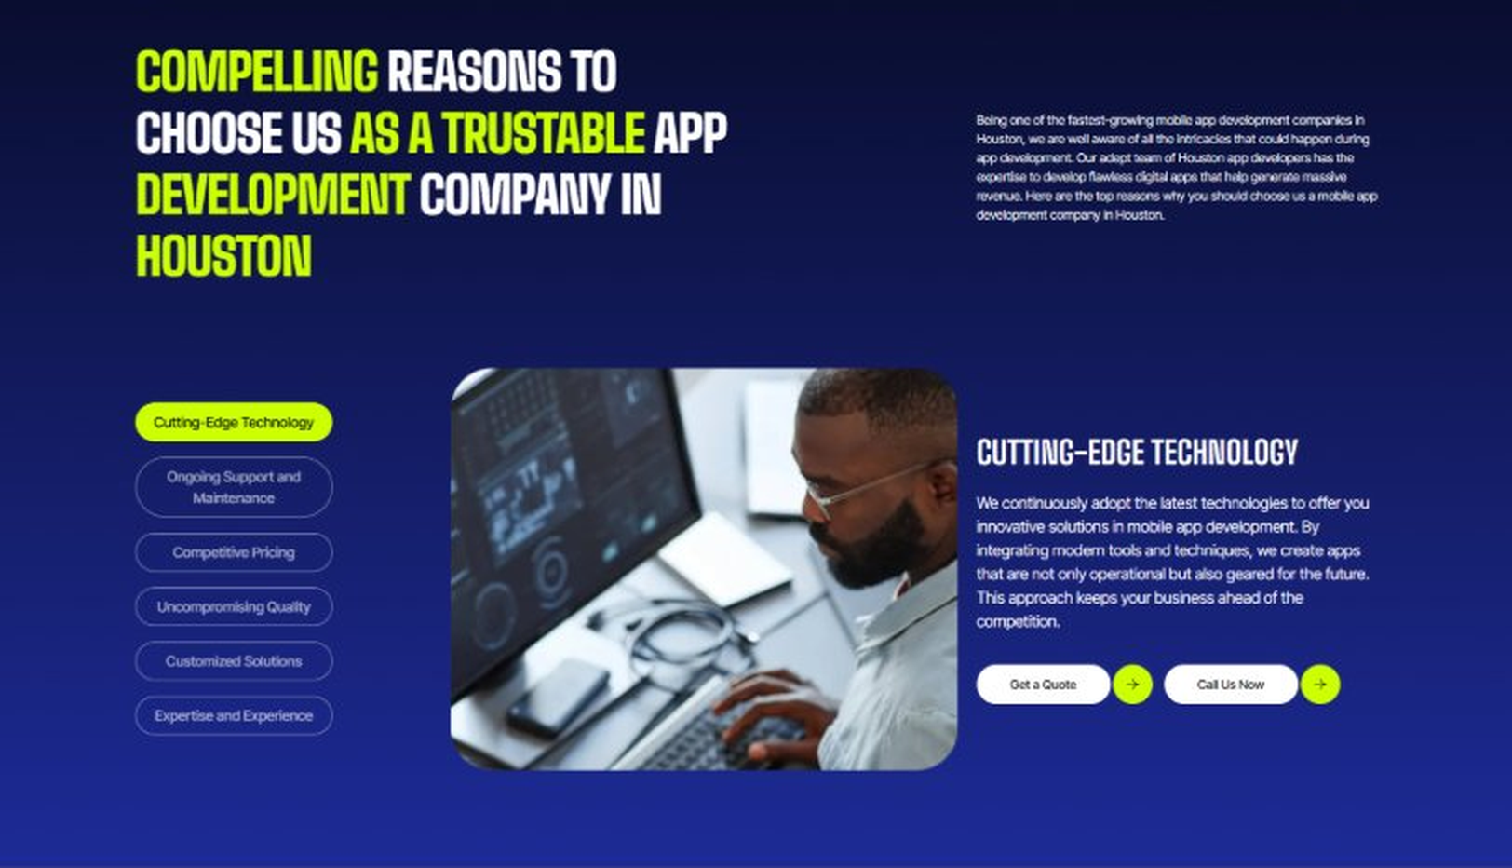
Current live page, www.appsters.io/industry
 | DETAIL
Status | New copy applied
Build Notes | Live block holds 6 tabs. New copy holds 6 reasons. Clean one to one fit, no design change needed.
Copy For This Fold
PAGE ELEMENT | COPY (WORD FOR WORD)
H2 (Section Heading) | Why Communities Choose Appsters As Their Trusted Social Media App Partner
Body Copy | Choosing a social media app development partner shapes whether your platform survives its first year. Our team blends product thinking, engineering discipline, and safety expertise to build apps that retain users, not just acquire them. Here's what that looks like in practice.
Reason 1 Heading | Engagement-First Architecture
Reason 1 Copy | We design every feature around what actually keeps people scrolling, chatting, and coming back, backed by real behavioral data rather than assumptions.
Reason 2 Heading | Built-In Content Moderation
Reason 2 Copy | Safety isn't bolted on later. Our moderation systems combine AI filtering with human review workflows from day one, protecting your brand and your users.
Reason 3 Heading | Viral-Load Engineering
Reason 3 Copy | Our architecture is stress-tested for sudden traffic spikes, so a viral moment becomes a growth opportunity instead of a downtime headline.
Reason 4 Heading | Creator Monetization Built In
Reason 4 Copy | From tipping to subscriptions to in-app marketplaces, we design monetization tools that keep creators earning and platforms growing.
Reason 5 Heading | Transparent Development Cycles
Reason 5 Copy | We follow sprint cadences with review checkpoints and shared roadmaps, so clients always know what's shipping and what's improving.
Reason 6 Heading | Long-Term Platform Thinking
Reason 6 Copy | We structure apps as ecosystems that evolve with user behavior and market trends, built for longevity rather than a single launch cycle.
FOLD 10: Sector Tabs
Sector Tabs: Serving 40+ Sectors With Mobile App Development In Houston
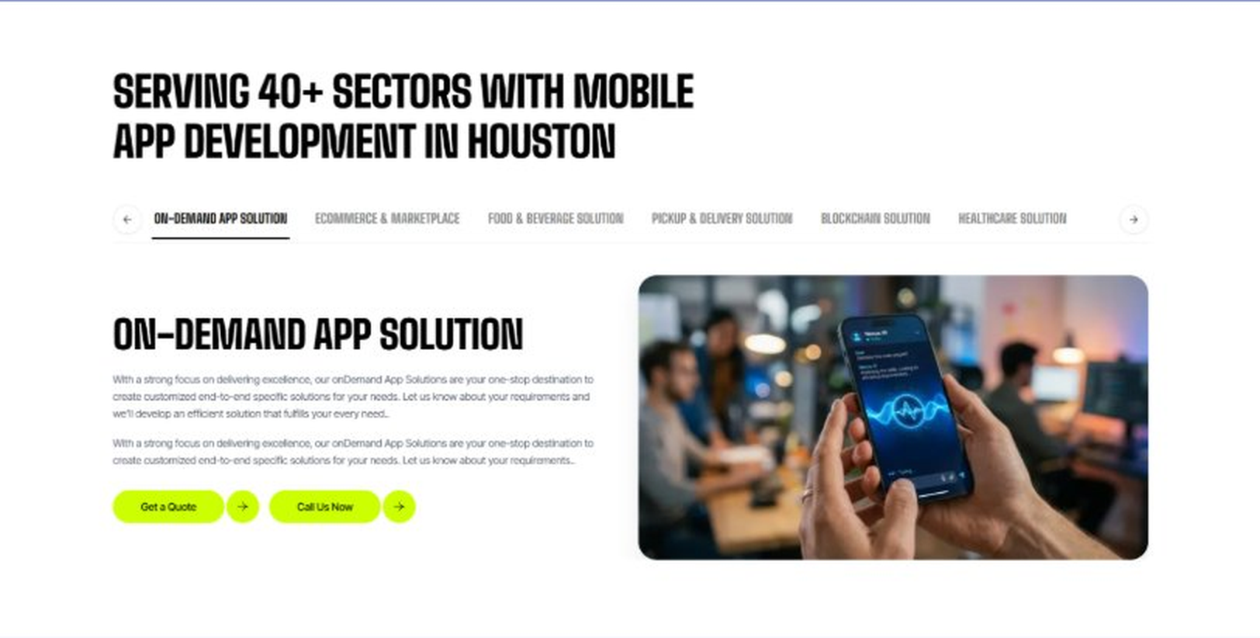
Current live page, www.appsters.io/industry
 | DETAIL
Status | New copy applied
Build Notes | Live block holds 6 sector tabs. New copy holds 5 solutions. Drop one tab or brief a sixth solution.
Copy For This Fold
PAGE ELEMENT | COPY (WORD FOR WORD)
H2 (Section Heading) | Social Media App Solutions Built For Every Type Of Community
Body Copy | Appsters delivers Social Media app solutions that cover everything from creator platforms to enterprise collaboration tools. Our systems are architected by senior Social Media app developers who focus on engagement mechanics, safety, and stable performance. Through our Social Media app development services, we help organizations build platforms that feel alive, relevant, and built to last, whether the end goal is a public-facing community or a closed network built for a single brand.
Solution 1 Heading | Event Management Apps
Solution 1 Copy | Our event-focused social tools help communities organize meetups, livestreams, and group activities directly inside the platform. RSVP tracking, reminders, and shared media galleries keep members engaged before, during, and after every event.
Solution 2 Heading | Corporate Events Apps
Solution 2 Copy | We build internal social platforms that help enterprises run town halls, team celebrations, and company-wide announcements with the same energy as consumer apps, minus the noise and distractions.
Solution 3 Heading | Subscription-Based Meal Apps
Solution 3 Copy | We build subscription-based social commerce tools where creators and local vendors offer recurring meal plans, drops, or perks directly to their most loyal followers, turning passive followers into paying subscribers.
Solution 4 Heading | Cloud Kitchen Apps
Solution 4 Copy | For platforms exploring social commerce, our cloud kitchen integrations connect creator-branded food ventures to in-app ordering, letting influencers launch delivery-only food brands without ever leaving their community feed.
Solution 5 Heading | Inventory Management Apps
Solution 5 Copy | Behind every social marketplace feature sits real inventory. We build inventory management tools that keep creator storefronts, drops, and merchandise accurate in real time, so nothing gets oversold during a viral moment.
FOLD 11: Engagement Models Table
Engagement Models Table: Flexible Engagement Models For Any App Development Need
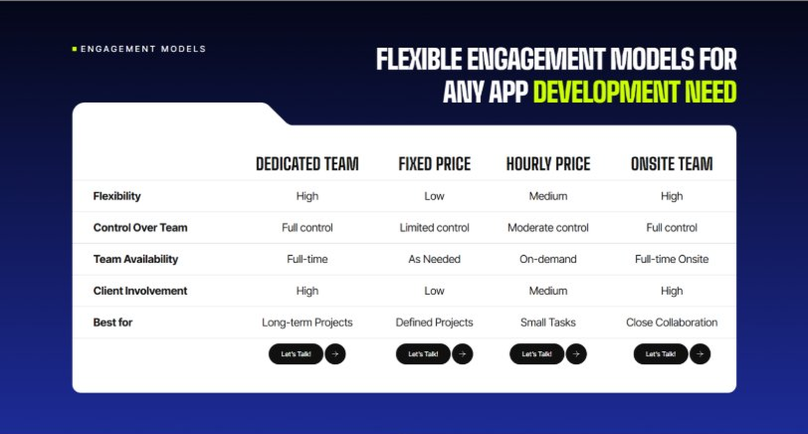
Current live page, www.appsters.io/industry
 | DETAIL
Status | No copy change
Build Notes | No new copy in the source document for this fold. Keep the live block exactly as it is.
FOLD 12: Game App CTA
Game App CTA: Into Engaging Mobile Games
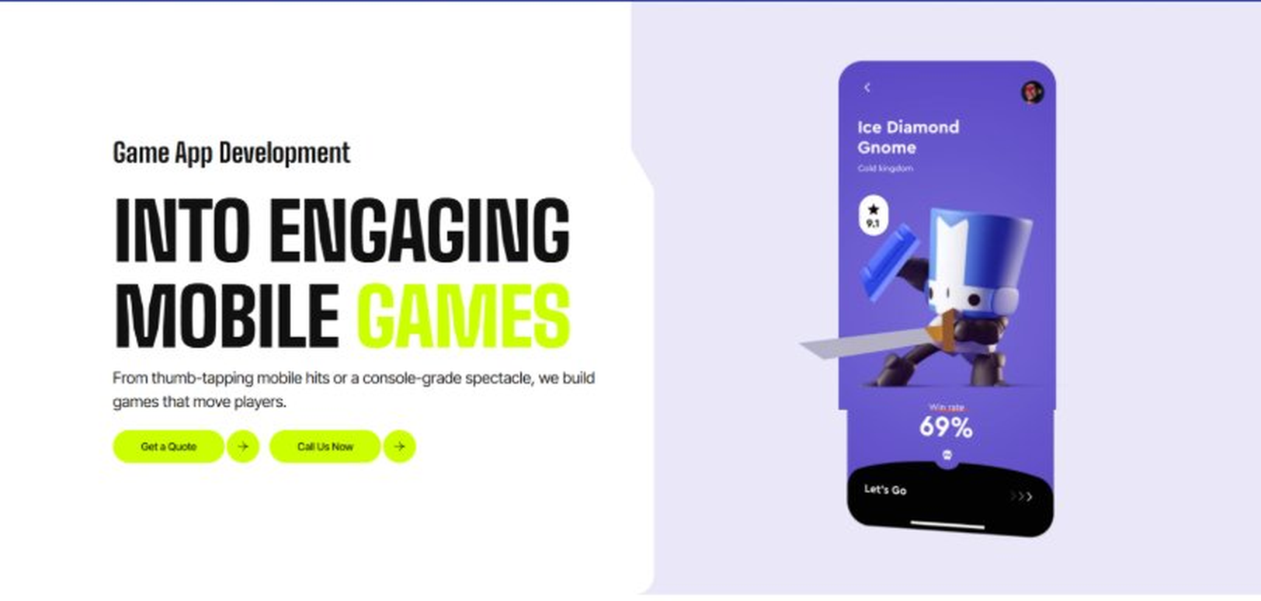
Current live page, www.appsters.io/industry
 | DETAIL
Status | No copy change
Build Notes | No new copy in the source document for this fold. Keep the live block exactly as it is.
FOLD 13: Collaboration And Client Logos
Collaboration And Client Logos
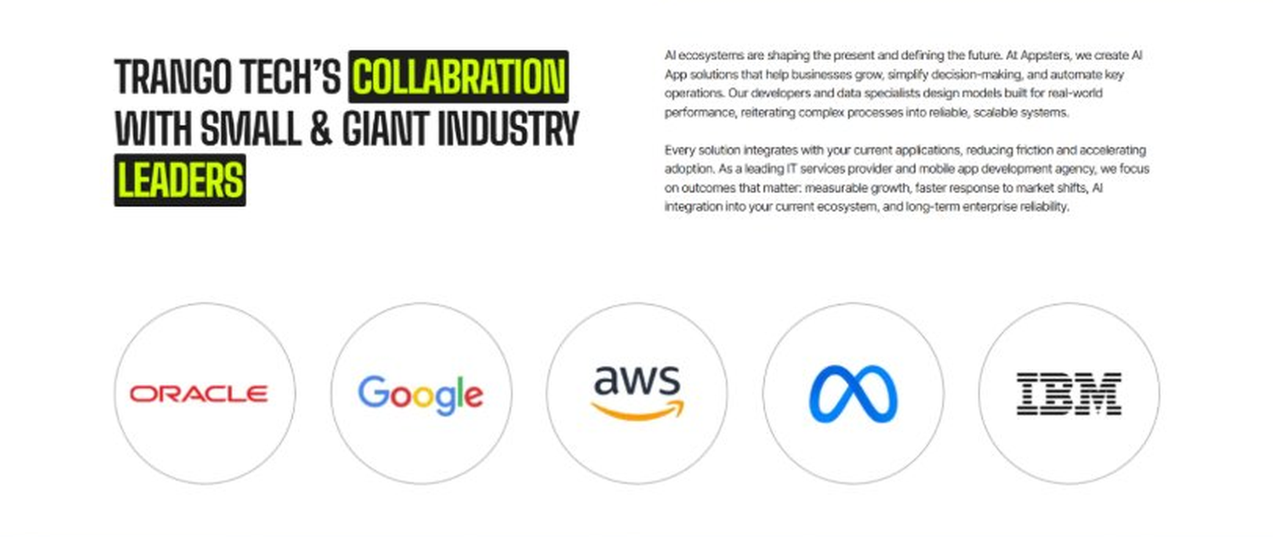
Current live page, www.appsters.io/industry
 | DETAIL
Status | No copy change
Build Notes | No new copy in the source document for this fold. Keep the live block exactly as it is.
QA Flag | Live heading reads "Trango Tech’s Collabration with Small & Giant Industry Leaders". That is a competitor name plus a spelling error sitting live on the page. Fix regardless of this content drop.
FOLD 14: Recognition CTA Banner
Recognition CTA Banner
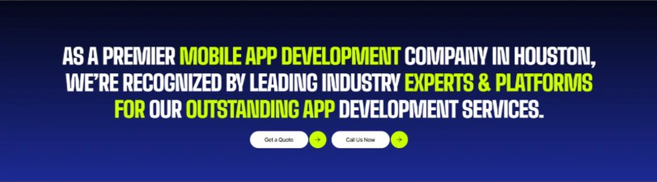
Current live page, www.appsters.io/industry
 | DETAIL
Status | New copy applied
Build Notes | Live block holds a headline and two CTA buttons. New copy supplies the heading and paragraph.
Copy For This Fold
PAGE ELEMENT | COPY (WORD FOR WORD)
H2 (Section Heading) | The Feed Never Stops Scrolling. Is Your Platform Ready To Launch?
Body Copy | Every day you wait is a day another app is fighting for your users' attention. Let's build a Social Media app that earns it and keeps it. Talk to Appsters today, and let's figure out what your first release actually needs to look like.
FOLD 15: Market Presence And Office Map
Market Presence And Office Map: Expand Your Market Presence
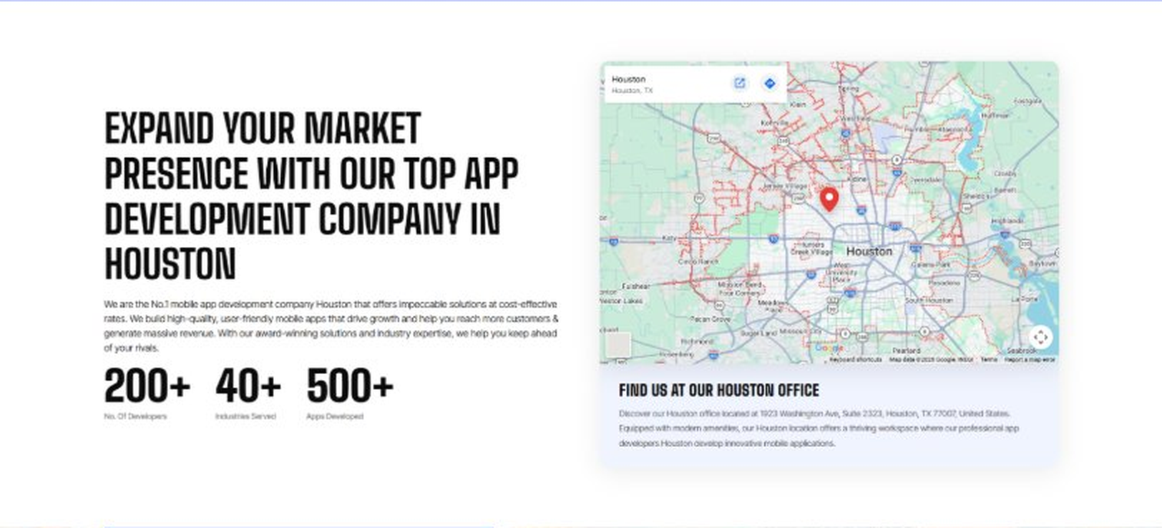
Current live page, www.appsters.io/industry
 | DETAIL
Status | New copy applied
Build Notes | Live block holds a heading, a paragraph, three counters and the office map. New copy supplies the heading and paragraph.
Copy For This Fold
PAGE ELEMENT | COPY (WORD FOR WORD)
H2 (Section Heading) | Food Ordering App Development Company Expertise Behind Every Social Platform We Build
Body Copy | As a team that knows how to develop mobile Social Media apps at scale, we bring the same rigor to embedded commerce features. Our engineers have shipped AI-based food delivery apps, in-app marketplaces, and live commerce tools, giving us a deep bench of experience most pure social app studios don't have. React Native, Swift, Kotlin, Node.js, and WebRTC form our core stack, paired with AI models tuned for feed ranking, fraud detection, and content moderation. Where most competitors bolt commerce onto social apps as an afterthought, we design it in from day one.
FOLD 16: Portfolio
Portfolio: Quick Glimpse On Our Portfolio

Current live page, www.appsters.io/industry
 | DETAIL
Status | New copy applied
Build Notes | Live block holds a heading, a paragraph and one CTA. New copy holds an intro plus 4 named product cards. Source document marks this fold design TBD.
Copy For This Fold
PAGE ELEMENT | COPY (WORD FOR WORD)
H2 (Section Heading) | Social Media Products Engineered For Long-Term Engagement
Body Copy | Appsters builds social platforms that behave like long-term ecosystems, not launch-week experiments. Our solutions stand out because they blend content design, moderation infrastructure, and behavioral analytics in one stable system. Every product is architected for retention, safety, and emotional relevance across communities of every size. Below are a few of the platforms we've taken from a rough concept to a live product with real, active users.
Product 1 Heading | CircleUp
Product 1 Copy | CircleUp is an interest-based community platform built for niche audiences that outgrew generic social apps. The platform blends threaded discussions, live rooms, and creator monetization tools into one clean experience. Moderation runs on a hybrid of AI filtering and community-elected moderators, keeping spaces safe without slowing conversation down.
Product 2 Heading | PulseFeed
Product 2 Copy | PulseFeed is a short-form video and content-sharing app designed for fast discovery and high retention. Adaptive recommendation engines learn viewing habits within minutes, while creator tools handle editing, monetization, and analytics in one dashboard. Built-in safety layers screen content before it ever reaches a feed.
Product 3 Heading | SnapCircle
Product 3 Copy | SnapCircle is a close-friends messaging and story-sharing app built around small, private groups instead of public broadcasting. Disappearing content, location-based check-ins, and shared albums keep interactions personal. The backend handles heavy media traffic without lag, even during peak sharing hours.
Product 4 Heading | VibeStream
Product 4 Copy | VibeStream is a live-streaming and audio-room platform built for creators who monetize real-time engagement. Virtual gifting, subscription tiers, and multi-guest rooms run on infrastructure tuned for low-latency streaming at scale. Analytics dashboards give creators clear visibility into what is actually working.
Source document note: Portfolio fold, design TBD after content
FOLD 17: Tech Stack Tabs
Tech Stack Tabs: Mobile App Development, A Tech Stack For The Bold
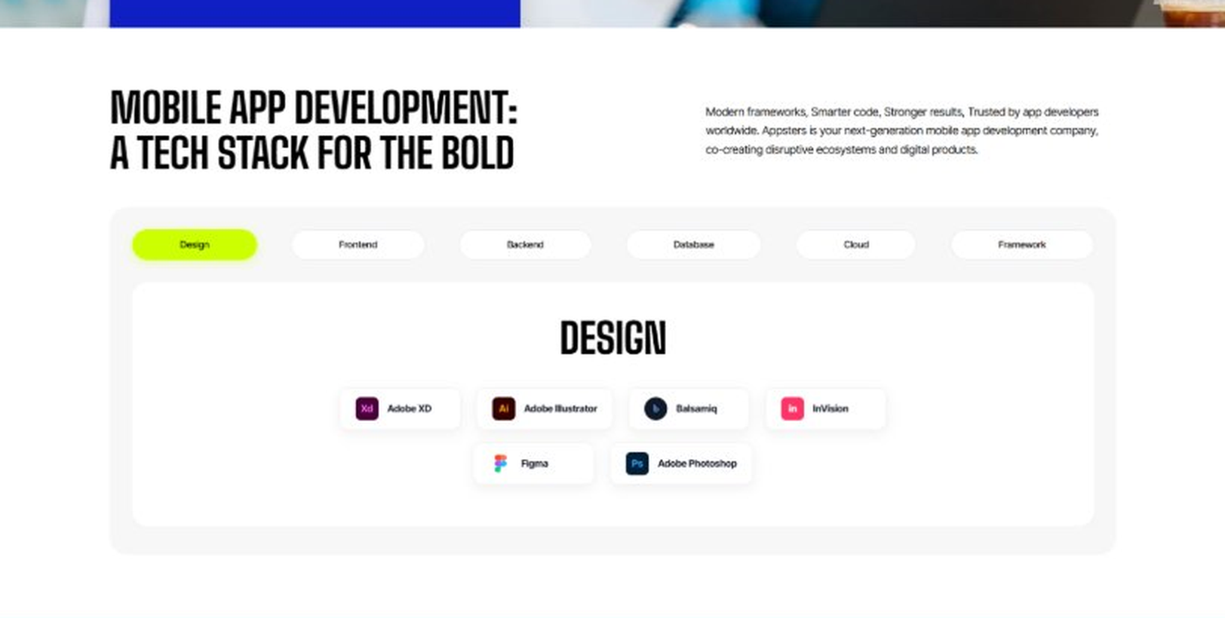
Current live page, www.appsters.io/industry
 | DETAIL
Status | New copy applied
Build Notes | Live block holds 6 category tabs with tool logos. New copy supplies the heading and paragraph, the tab contents stay as they are.
Copy For This Fold
PAGE ELEMENT | COPY (WORD FOR WORD)
H2 (Section Heading) | Technology Stack That Powers High-Performance Social Media Applications
Body Copy | Our engineering foundation supports real-time feeds, heavy media traffic, and platform-wide scalability. Through our Social Media application development services, we use Swift, Kotlin, Flutter, React Native, Node.js, WebRTC, GraphQL, and secure cloud infrastructure alongside AI-driven recommendation engines. Every stack decision reinforces speed, safety, and long-term flexibility so your platform can grow without a rebuild, whether that growth happens gradually or all at once after a single viral post.
FOLD 18: Process
Process: App Development Process
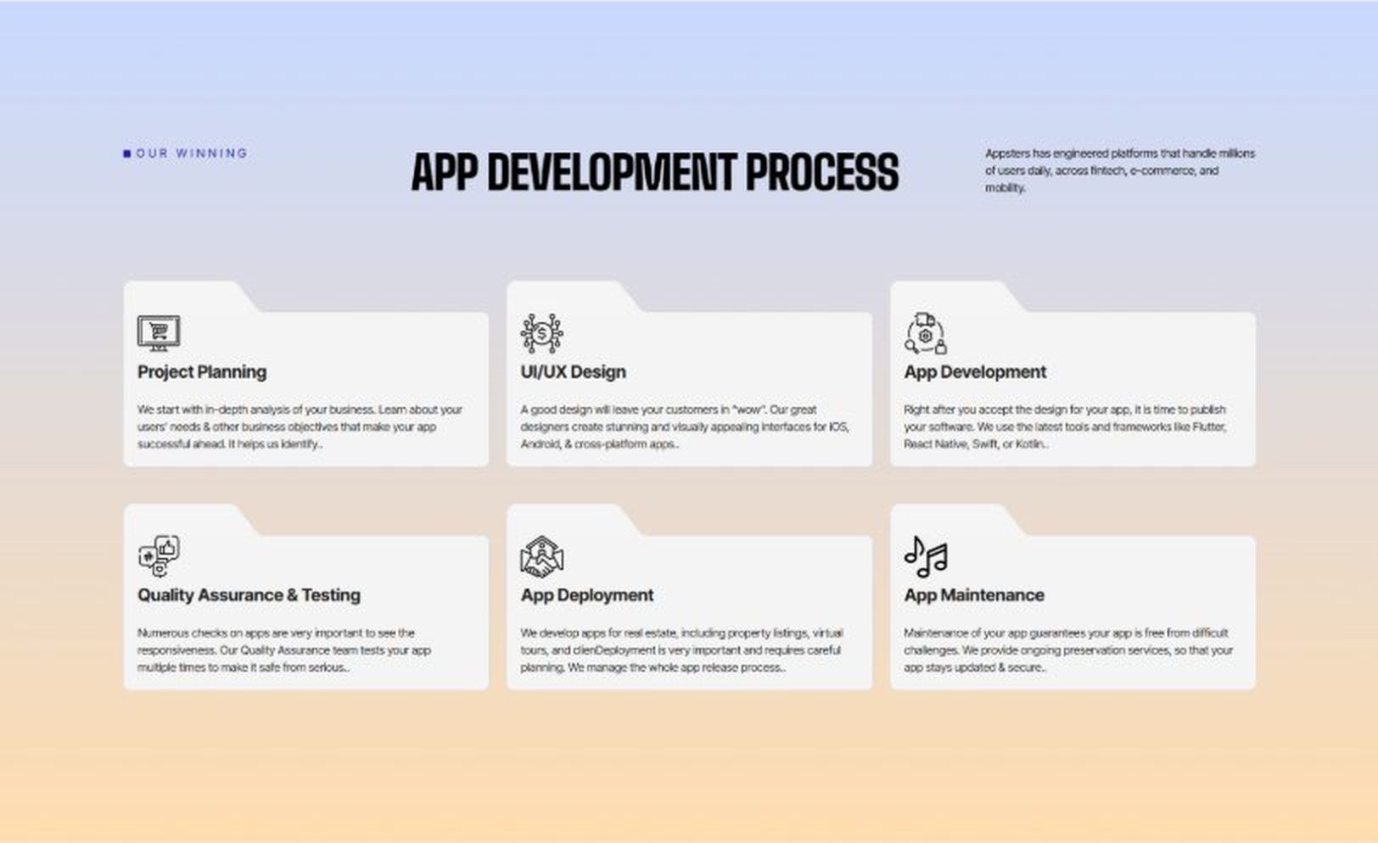
Current live page, www.appsters.io/industry
 | DETAIL
Status | New copy applied
Build Notes | Live block holds 6 step cards. New copy holds 8 steps. Either widen the block to 8 or merge two steps.
Copy For This Fold
PAGE ELEMENT | COPY (WORD FOR WORD)
H2 (Section Heading) | Social Media App Development Process Built For Platforms That Actually Launch
Body Copy | A social platform needs more than a clean UI. It needs structure, clarity, and a process engineered for scale, safety, and retention from day one. Our Social Media app development process aligns product goals with technical roadmaps so every phase moves with intention, and so nothing gets rebuilt from scratch six months after launch because a shortcut caught up with us.
Step 1 Heading | App Idea & Research
Step 1 Copy | Every project begins with structured discovery, where our teams map audience behavior, competitor platforms, monetization models, and content moderation needs. We benchmark engagement patterns across existing apps and define what will make your platform worth opening every day. By the time research closes, the product's purpose, risks, and growth path are already clear.
Step 2 Heading | Strategic Planning & Consultation
Step 2 Copy | Here we translate research into a measurable plan. Our strategists define the technical architecture, safety policies, monetization strategy, and delivery milestones needed to build your AI Social Media mobile app the right way, from the first sprint.
Step 3 Heading | Wireframing & Prototyping
Step 3 Copy | We turn ideas into tangible user journeys. Wireframes capture navigation, feed logic, and interaction design in a visual structure stakeholders can react to before a single line of code gets written. Every screen gets tested against real user behavior patterns.
Step 4 Heading | App Development
Step 4 Copy | This is where engineering takes over. Our developers implement feed algorithms, chat systems, moderation tools, and monetization features with the same discipline a food app development company applies to order accuracy and uptime. Development stays sprint-driven and transparent throughout.
Step 5 Heading | Expert QA & Testing
Step 5 Copy | Quality assurance covers far more than bug hunting. We validate performance under viral load, content moderation accuracy, cross-device behavior, and data privacy compliance. Only stable, predictable behavior earns approval to move forward.
Step 6 Heading | App Launch
Step 6 Copy | Launch is a coordinated rollout, not a leap of faith. We manage store compliance, metadata strategy, onboarding polish, and final performance checks so your platform enters the market ready to hold real traffic.
Step 7 Heading | Deployment
Step 7 Copy | Our deployment pipelines are built for consistency and safety. We configure cloud infrastructure, optimize CDNs for media-heavy content, and calibrate autoscaling so your app performs the same at 10,000 users as it does at 10 million.
Step 8 Heading | Maintenance & Support
Step 8 Copy | Post-launch, we keep monitoring engagement patterns, refining feed logic, patching vulnerabilities, and responding to new platform policies or app store guidelines, so your community keeps growing long after day one.
Source document note: Process fold, design TBD after content
FOLD 19: Blog Posts
Blog Posts: Our Related Blog Posts
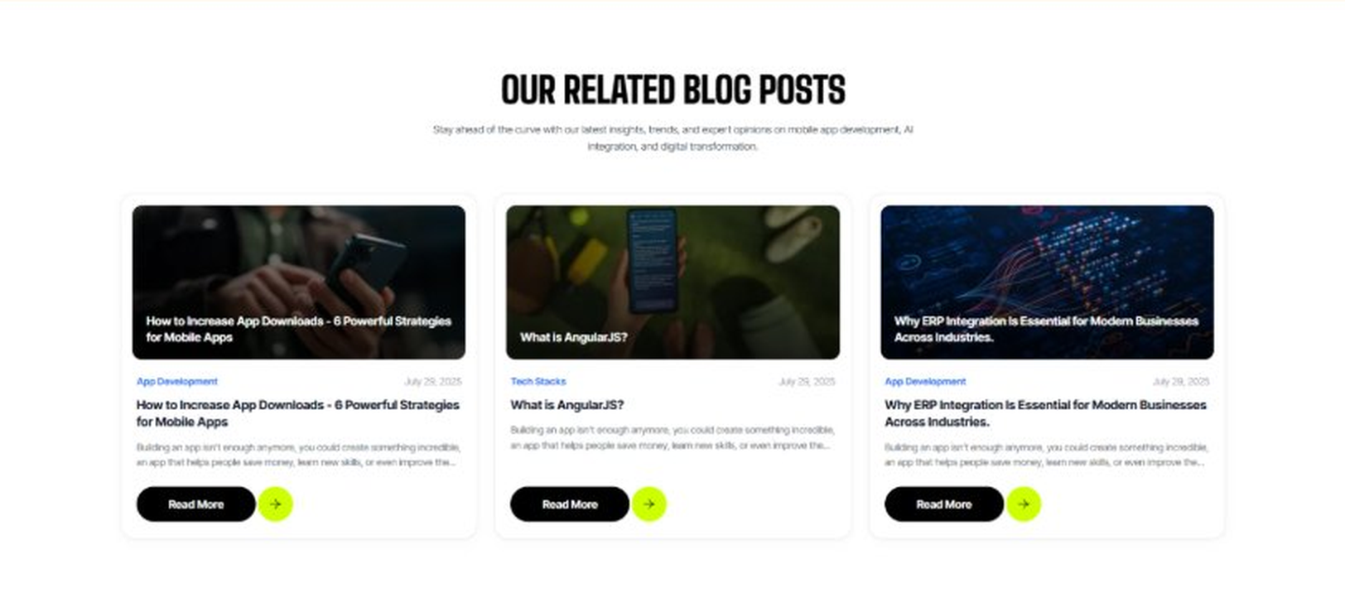
Current live page, www.appsters.io/industry
 | DETAIL
Status | No copy change
Build Notes | No new copy in the source document for this fold. Keep the live block exactly as it is.
FOLD 20: FAQs
FAQs: Your Questions, Our Clarity
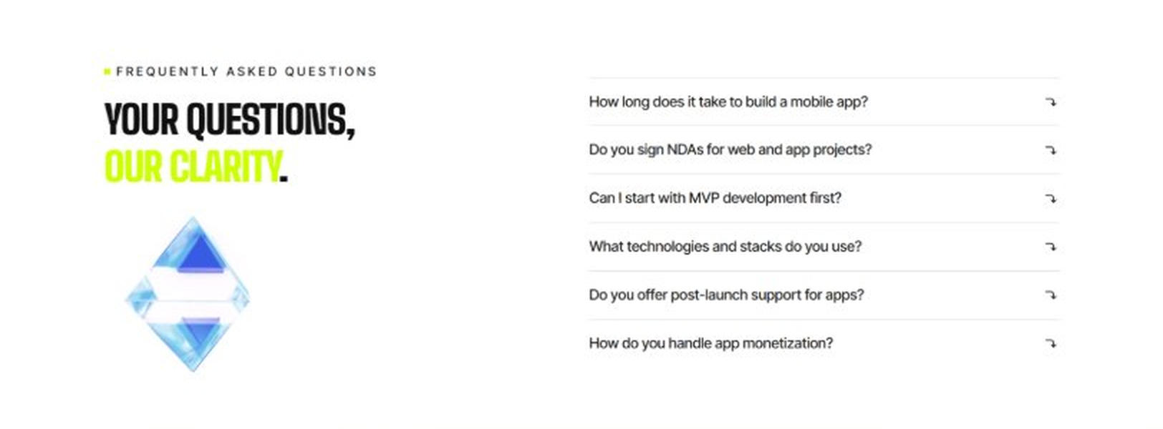
Current live page, www.appsters.io/industry
 | DETAIL
Status | New copy applied
Build Notes | Live block holds 6 accordion rows. New copy holds 6 questions and answers. Clean one to one fit.
Copy For This Fold
PAGE ELEMENT | COPY (WORD FOR WORD)
H2 (Section Heading) | Frequently Asked Questions
FAQ 1 Question | How long does it typically take to build a fully functional social media app?
FAQ 1 Answer | Timelines depend on feature complexity, moderation requirements, and infrastructure needs. Most projects take 12 to 20 weeks for a stable release, including design, engineering, QA, and beta testing. As a social media app development company, we provide clear milestones from day one.
FAQ 2 Question | Can Appsters build an AI Social Media app with smart content recommendations?
FAQ 2 Answer | Yes. We build AI Social Media apps with recommendation engines, sentiment analysis, and automated moderation baked into the core architecture, not added as an afterthought.
FAQ 3 Question | Do you support in-app commerce features as a food delivery app development company would?
FAQ 3 Answer | Absolutely. Many of our Social Media app developers have direct experience building commerce and delivery flows, so we can embed ordering, payments, and tracking directly into your social platform.
FAQ 4 Question | What makes Appsters different from other Social Media mobile app development company options?
FAQ 4 Answer | We treat safety, retention, and infrastructure as core product decisions, not add-ons. Most Social Media app development companies focus on UI first and scale later. We do both from the start.
FAQ 5 Question | Can you handle sudden traffic spikes if our app goes viral?
FAQ 5 Answer | Yes. Our architecture is stress-tested for viral load specifically, so a sudden surge in users becomes a growth milestone instead of a downtime incident.
FAQ 6 Question | What ongoing support do you provide after launch?
FAQ 6 Answer | Our Social Media app development services include post-launch monitoring, feature updates, moderation tuning, and infrastructure scaling, so your platform keeps improving long after release.
FOLD 21: Locations
Locations: Our Global Presence
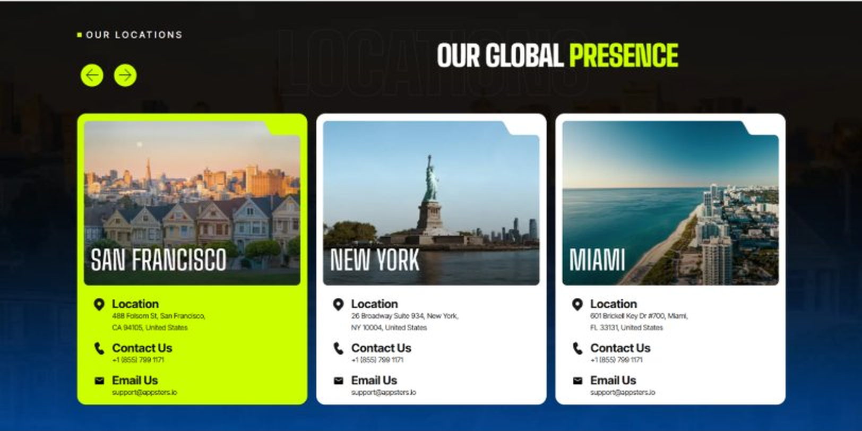
Current live page, www.appsters.io/industry
 | DETAIL
Status | No copy change
Build Notes | No new copy in the source document for this fold. Keep the live block exactly as it is.
FOLD 22: Contact Form
Contact Form: Connect With Us
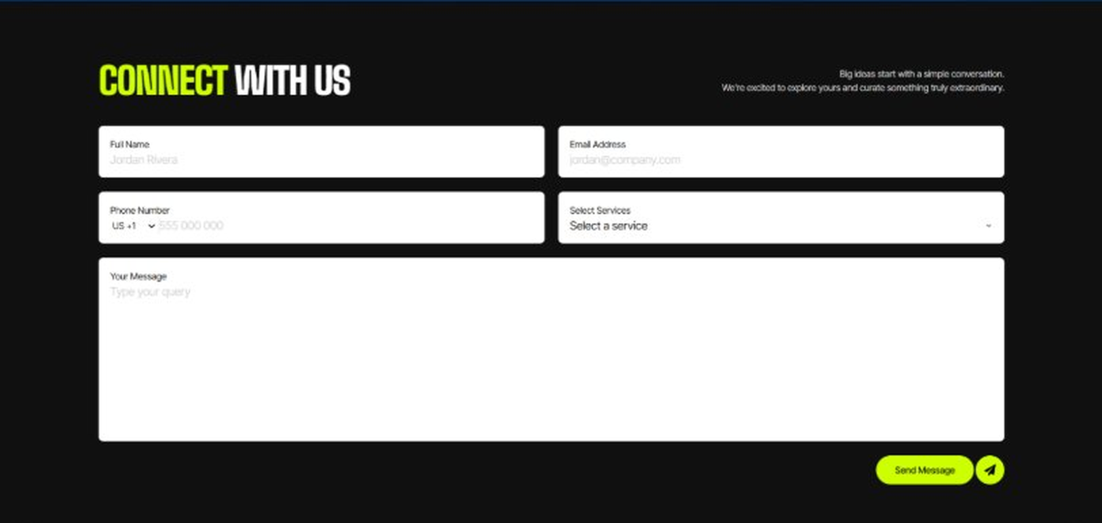
Current live page, www.appsters.io/industry
 | DETAIL
Status | No copy change
Build Notes | No new copy in the source document for this fold. Keep the live block exactly as it is.
FOLD 23: Footer
Footer
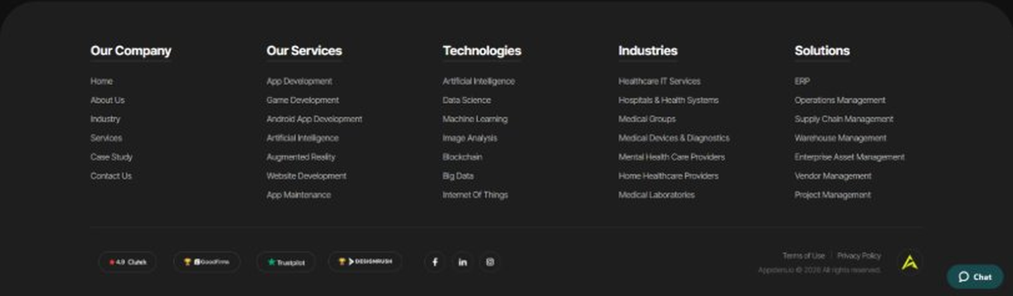
Current live page, www.appsters.io/industry
 | DETAIL
Status | No copy change
Build Notes | No new copy in the source document for this fold. Keep the live block exactly as it is.
NEW BLOCKS REQUIRED
The three blocks below are in the source content but have no matching section anywhere on the current /industry page. Each one needs a new block built.
NEW BLOCK: Distinct Features That Set Our Social Media Apps Apart
 | DETAIL
Status | No equivalent block on the live page
Placement | Suggested placement: directly after Fold 5, reusing the services card grid styling.
Copy For This Block
PAGE ELEMENT | COPY (WORD FOR WORD)
H2 (Section Heading) | Distinct Features That Set Our Social Media Apps Apart
Feature 1 Heading | Dashboard & Admin Panel
Feature 1 Copy | A centralized control center gives your team visibility into user activity, content flags, and platform health without digging through raw data.
Feature 2 Heading | Push Notifications
Feature 2 Copy | Smart, behavior-based notifications bring users back at the right moment instead of spamming them into disabling alerts entirely.
Feature 3 Heading | Digital Menu
Feature 3 Copy | A structured, browsable content menu lets users navigate categories, trending topics, and creator collections without getting lost in an endless scroll.
Feature 4 Heading | Order Tracking
Feature 4 Copy | For platforms with in-app commerce, real-time order tracking keeps buyers informed from purchase to delivery without ever leaving the app.
Feature 5 Heading | Social Media Integration
Feature 5 Copy | Cross-posting, single sign-on, and content syndication let users connect existing social accounts and share content across platforms without friction.
NEW BLOCK: Industries We Serve
 | DETAIL
Status | No equivalent block on the live page
Placement | Suggested placement: directly after Fold 10, as a card grid rather than tabs.
Copy For This Block
PAGE ELEMENT | COPY (WORD FOR WORD)
H2 (Section Heading) | Industries We Serve
Body Copy | One Codebase. Infinite Industries. Our web, app, and AI solutions are built to perform, scale, and adapt while setting industry standards and redefining what's possible for businesses everywhere.
Industry 1 Heading | Fintech
Industry 1 Copy | We co-create secure, compliant fintech apps that simplify payments, investments, and trading, with the same infrastructure discipline we bring to high-traffic social platforms.
Industry 2 Heading | Healthcare
Industry 2 Copy | We develop HIPAA-compliant healthcare apps that bridge doctors, patients, and data, applying the same real-time messaging and notification systems we build for social platforms.
Industry 3 Heading | Education
Industry 3 Copy | Our education apps gamify learning and power virtual classrooms, borrowing engagement mechanics straight from consumer social platforms to keep students coming back.
Industry 4 Heading | Real Estate
Industry 4 Copy | We design real estate apps that help buyers, sellers, and agents close deals faster, with social-style discovery feeds and in-app messaging built in.
Industry 5 Heading | Automotive
Industry 5 Copy | From fleet dashboards to car rental apps, we digitize automotive operations with real-time tracking and communication tools drawn from our social app expertise.
Industry 6 Heading | Music
Industry 6 Copy | We create streaming apps and artist marketplaces that let music businesses scale and monetize, powered by the same recommendation engines behind our social platforms.
Industry 7 Heading | Logistics
Industry 7 Copy | We power logistics apps with route optimization and real-time tracking, using the same live-notification infrastructure that keeps social feeds instant.
Industry 8 Heading | Ecommerce
Industry 8 Copy | We build ecommerce apps with frictionless checkouts and AI product recommendations, blending social discovery with commerce the way modern shoppers expect.
NEW BLOCK: Advanced Technologies That Power Our Social Media Apps
 | DETAIL
Status | No equivalent block on the live page
Placement | Suggested placement: directly after Fold 17, reusing the services card grid styling.
Copy For This Block
PAGE ELEMENT | COPY (WORD FOR WORD)
H2 (Section Heading) | Advanced Technologies That Power Our Social Media Apps
Body Copy | As a social media app development company built around what's next, we don't stop at feeds and chat. Every social media app developer on our team stays current with tools that keep platforms competitive, from AI moderation to live commerce. Unlike most social media app development companies still catching up on food ordering app development trends inside social platforms, we're already building AI-based social media apps with these capabilities baked in. That head start usually shows up in the first release, not two years down the line.
Technology 1 Heading | AI Integrated Social Media Apps
Technology 1 Copy | We build AI Integrated Social Media Apps with smart feed ranking, sentiment analysis, and automated content moderation, giving users a feed that actually feels relevant.
Technology 2 Heading | Payment Gateway Integration
Technology 2 Copy | Secure, PCI-compliant payment gateway integration lets your platform handle tipping, subscriptions, and marketplace transactions without third-party friction.
Technology 3 Heading | Cloud Solutions
Technology 3 Copy | Our cloud solutions keep media-heavy platforms fast and reliable, with autoscaling infrastructure built to absorb sudden traffic spikes.
Technology 4 Heading | MVP For Social Media Apps
Technology 4 Copy | When you need to validate an idea fast, our MVP for Social Media Apps approach gets a functional, testable product into real users' hands without a twelve month build cycle.
Technology 5 Heading | API Integration
Technology 5 Copy | We connect your platform to third-party services, analytics tools, and other social ecosystems through clean, well-documented API integration.

